**Linux User Management Command:**

1. Add newuser 🡪 **sudo adduser <username>**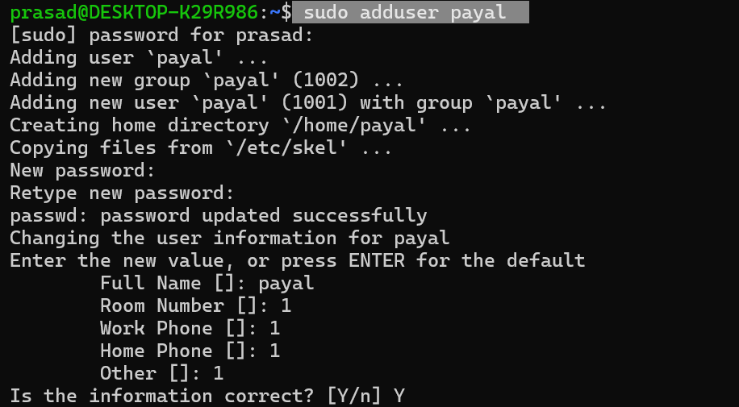
2. Reset Password 🡪 **sudo passwd <newuser>**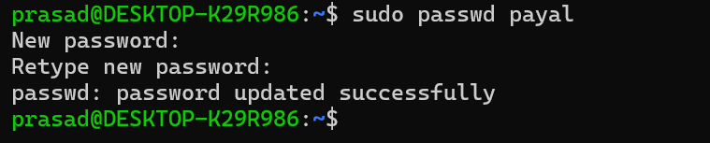
3. Delete user 🡪 **sudo deluser <username>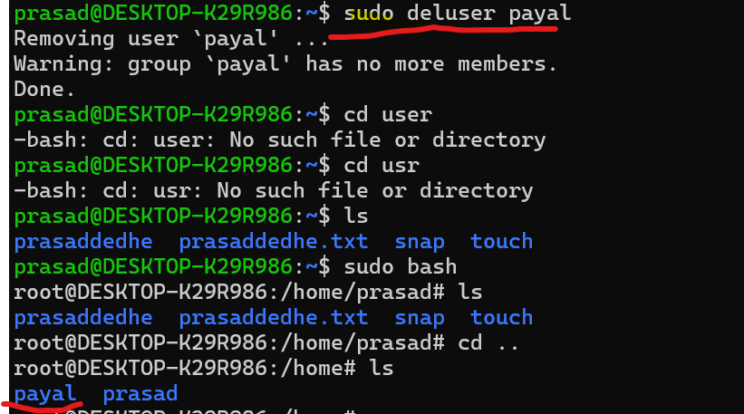**Remember even if the user has been deleted the directory of the username has not been deleted, it has to be deleted manually.
4. Disable a user 🡪 **sudo usermod --lock <username>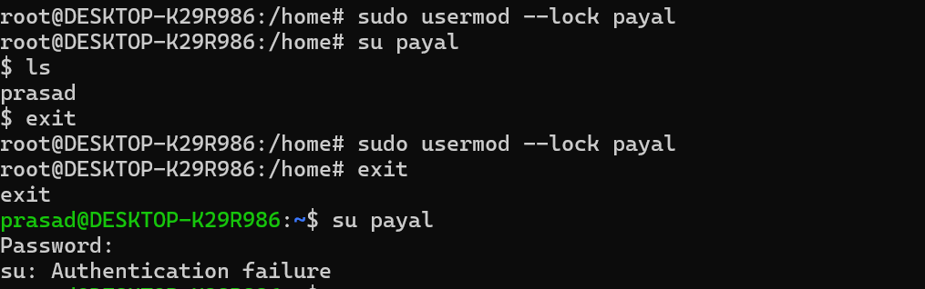**Remember even if a user is locked then also the root user is able to access the user.
5. Enable a user 🡪 **sudo usermod –unlock <username>**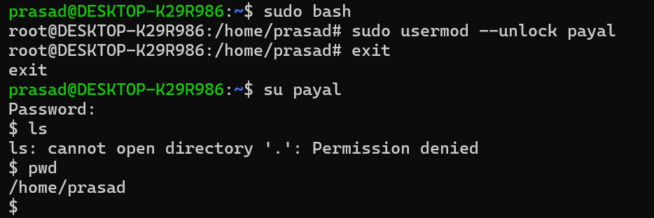
6. Change ownership of directory or file 🡪 **sudo chown <user> <dir or file>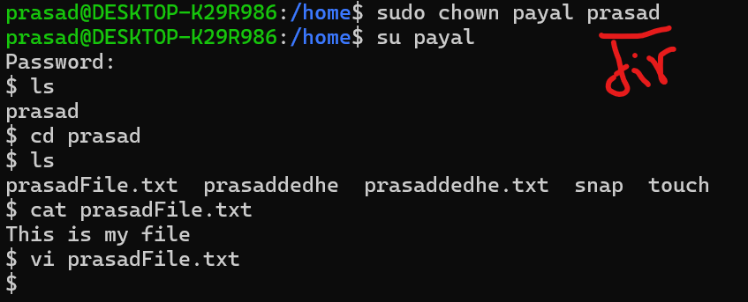**Remember once you transfer the ownership of the dir the user who previously was owner loses the access! See below, prasad not allowed to write the files anymore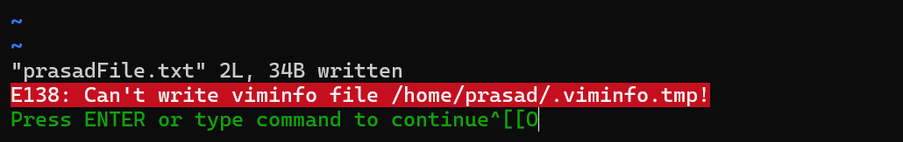
7. How to set expiry date 🡪 **sudo usermod --expiredate YYYY-MM-DD <username> 🡪** Remember by mistake I set a backdated expiry date on my system for my own user, which instantly blocked me from accessing the system. I had to uninstall and reinstall ubuntu for this.
8. Add new user to a group 🡪 **sudo groupadd <groupname>**
9. Add a user in that group 🡪 **sudo usermod -aG <group> <user>**
10. Remove the user from a group 🡪 **sudo gpasswd -d <username> <groupname>**
11. Give permission to a group on a file 🡪 **sudo chown :<groupname> <file_or_directory>**
    1. Create a user payal **🡪 useradd payal**
    2. Create a group executioners **🡪 groupadd executioners**
    3. Create a bash file **🡪 vi bs.sh**
    4. Add **echo “Success”** in it.
    5. Make the file executable**🡪 Chmod +x bs.sh**
    6. Make it owner of that group **🡪 chown :executioners bs.sh**
    7. **Chmod 050 bs.sh** 🡪 Gives group who is owner of the file read and execute permissions
    8. Now try executing using prasad, you won’t be able to **🡪 ./bs.sh**
    9. **Now switch user to payal & try to run, it will run!** 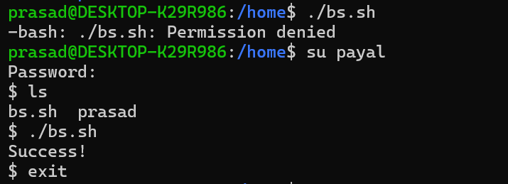
12. Now let’s say you have two groups, in which services are there, you want to have services in both of the groups to have execute access on the file, then what to do? Keep in mind,
    1. There cannot be two owner groups for a single file
    2. We only want two group services to have the access, other services in other groups should not have access, so we cannot do chmod 050 filename.
13. In above situation, we need to use ACL 🡪 Access Control List, this will allow you to have multiple groups to have access on the file but owner would still be one.
    1. **Sudo apt install acl**
    2. **setfacl -m g:group1:x file.sh**
    3. **setfacl -m g:group2:x file.sh**
    4. **getfacl file.sh**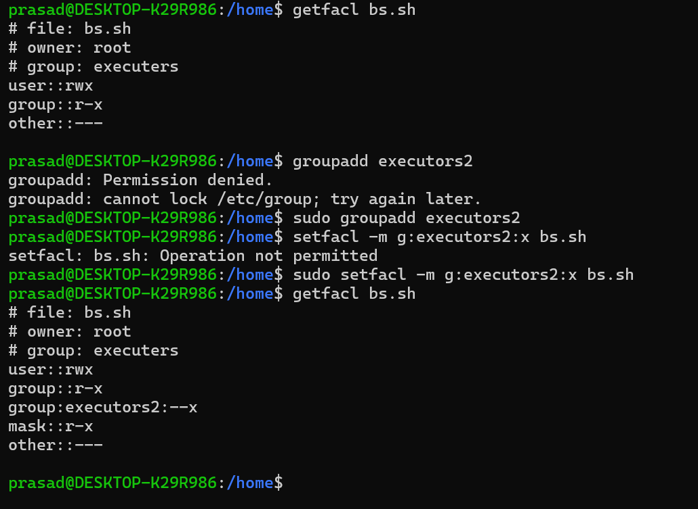
14. List of users 🡪 **sudo cut -d: -f1 /etc/passwd**
15. List of users and groups 🡪 **cut -d: -f1 /etc/group**
16. List current user previlabes 🡪 **id <user>**  
    ****From above screenshot you can tell prasad is a sudoer but payal is not
17. Now you want to add payal into sudoers, you should do the below command,
    1. **sudo usermod -aG sudo payal**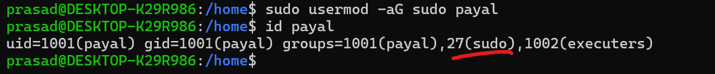
18. Which users are in a group? 🡪 **getnet group <groupname>**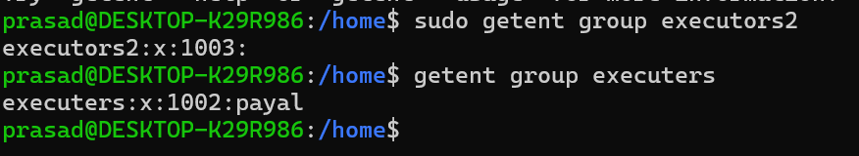
19. How to lock a user if user has been inactive, lets say for 30 days? **🡪 sudo usermod --inactive 30 <username>**
20. Lets see something is deleted and you have suspicion on someone, you want to check when did they last login, then use this command 🡪 **lastlog -u <username>**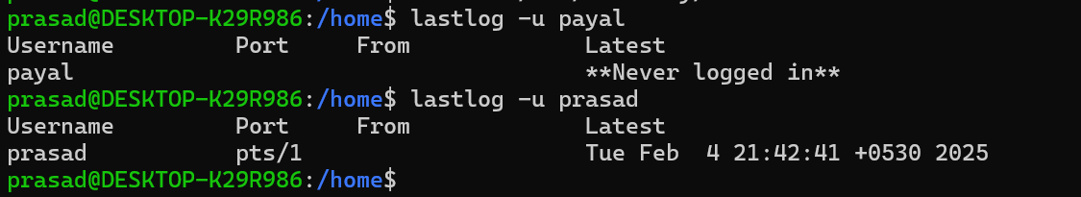
21. How to delete a group 🡪 sudo groupdel <group>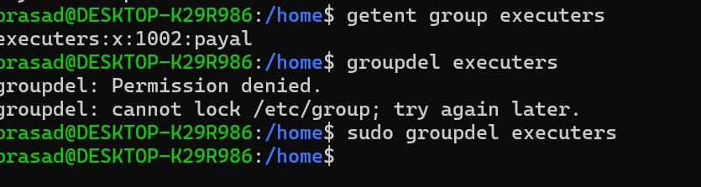
22. Also, remember, What happens to the files whose owner has been deleted from the system in ubuntu? 🡪 The simple answer is that files are orphaned and a sudo user can reassign the ownership of those files to others.